http://treasurer.maricopa.gov/
- Need to enter the parcel
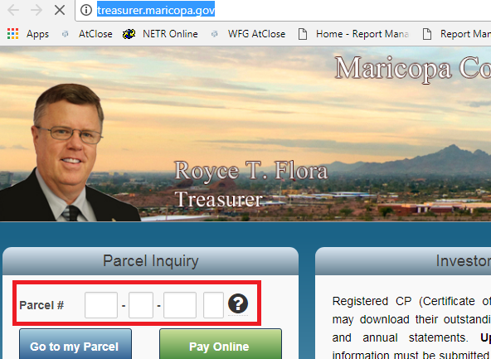

http://treasurer.maricopa.gov/Parcel/Summary.aspx
- Assessed Tax is Total Annual Base Amount, Tax Paid is total paid amount & Total Due is remaining due amount.
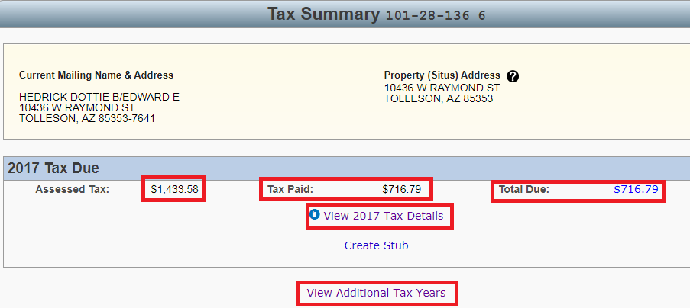

- If we click the view additional tax years, we can able to see prior year taxes
http://treasurer.maricopa.gov/Parcel/Summary.aspx?List=All
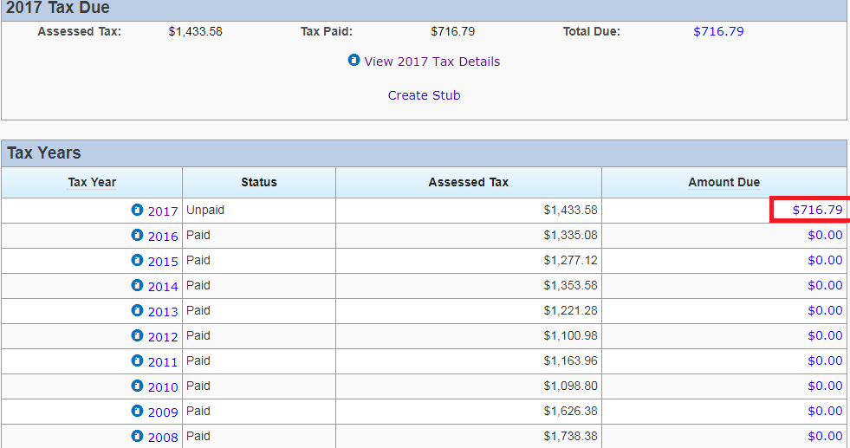
- If we click the amount due, we can able to see the due amount
http://treasurer.maricopa.gov/Parcel/TaxDue.aspx?TaxYear=2017

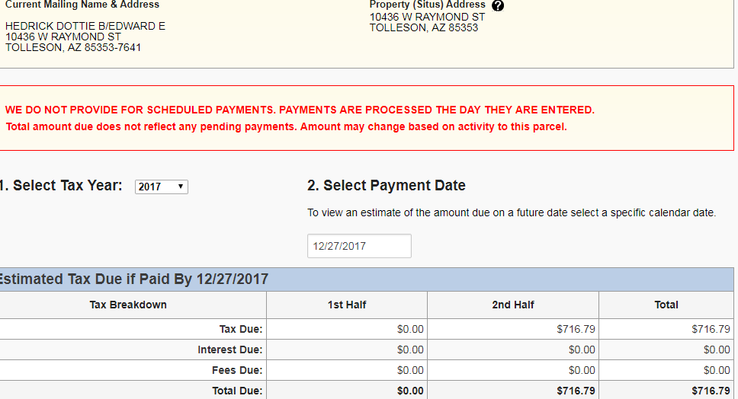

http://treasurer.maricopa.gov/Parcel/Summary.aspx
- If we need to see the paid date, click the tax information tab then click activities.
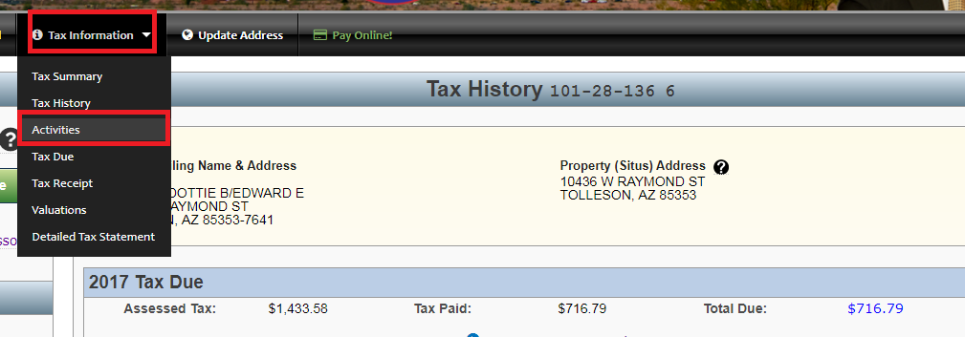

http://treasurer.maricopa.gov/Parcel/Activities.aspx
- We can able to see paid dates for all the tax years.
